SIMATS ENGINEERING (SAVEETHA SCHOOL OF ENGINEERING)

Department of Artificial Intelligence and Data Science
ASSESSMENT TOOL 3 – CODING CHALLENGE

Course Code: | DSA0311 | Course Title: | Natural Language Processing
CO Assessed: | CO1 – Imitation (L1) | Assessment: | Assessment Tool 3 – Coding Challenge
Weightage: | 30% of CIA
CO5 Statement: | Analyse NLP models, regular expression patterns, finite state automata, morphological processing techniques and to interpret language processing. (BL-3)
Student Name: | P. Nandu Vardhan | Reg. No.: | 192425067
Section / Batch: | B.tech AIML-2024 | Date: | 15-10-2026
Code of Conduct
I P. Nandu Vardhan / 192425067 (Name / Reg No) certify that this submission is my original work and that I have adhered to the guidelines specified for this assessment. I understand that any violation of academic integrity rules will result in disciplinary action.
Signature of the Student: 

Instructions
- Develop a complete and modular Python program that meets all the functional requirements specified in the coding challenge using appropriate algorithms, data structures, and programming practices.
- Test the program using multiple valid and invalid test cases, and clearly display the input, processing, and output to verify the correctness of the implementation.
- Follow standard coding practices by using meaningful variable names, proper indentation, comments, exception handling (where applicable), and upload the source code, sample outputs, and README file to the designated GitHub repository.
- Duration: 40 minutes.

Section / Topic | Focus | Q Nos
Regular Expression Pattern Matching | Regular Expressions, Basic Regular Expression Patterns | 1
Finite State Automata Implementation | Finite State Automata, Models and Algorithms | 2
Advanced Regular Expression Search | Regular Expressions, Basic Regular Expression Patterns | 3

Annexure A – Coding Challenge

Section 1: Intelligent Email and Password Validator using Regular Expressions
1. Problem Statement:
A software company is developing a user registration system. Before creating an account, the system must validate user credentials based on predefined security policies.

Develop a Python application that validates:
Email Address Password Mobile Number
using Regular Expressions.

Validation Rules
Email
Must start with an alphabet.
May contain letters, digits, '.', '_' before '@'. Domain should contain only alphabets.
Valid extensions: .com, .org, .edu, .net, .in

Password
Minimum 8 characters
At least one uppercase letter At least one lowercase letter At least one digit
At least one special character (@,#,$,%,&,!)

Mobile Number
Must contain exactly 10 digits. First digit should be between 6–9. Expected Output
Display:
Valid Email / Invalid Email
Strong Password / Weak Password
Valid Mobile Number / Invalid Mobile Number

Answer:

Regular Expressions – User Registration Validation System

Aim
To develop a Python application using Regular Expressions (Regex) to validate a user's email address, password, and mobile number according to predefined security rules.

Implementation Approach
Step 1: Accept User Details

Get the email address, password, and mobile number from the user using Python's input() function. Step 2: Validate Email Address

Use a Regex pattern to check whether the email starts with an alphabet, contains permitted characters before
@, has an alphabetic domain, and ends with an allowed extension such as .com, .org, .edu, .net, or .in. Step 3: Validate Password
Check whether the password contains at least eight characters, one uppercase letter, one lowercase letter, one digit, and one special character from @, #, $, %, &, !.
Step 4: Validate Mobile Number

Use a Regex pattern to verify that the mobile number contains exactly 10 digits and begins with a digit between 6 and 9.

Step 5: Display Validation Results

Display Valid Email or Invalid Email, Strong Password or Weak Password, and Valid Mobile Number or Invalid Mobile Number, depending on the validation results.

Key Part of the Algorithm
  - Read the email, password, and mobile number.
  - Define suitable Regex patterns for each field.
  - Use re.fullmatch() to check the complete email and mobile number.
  - Use lookahead assertions in the password pattern to check all password requirements.
  - Store each validation result as a Boolean value.
  - Display the appropriate validation message for each field.

Python Code
import re

# Get user details
email = input("Enter Email Address: ") password = input("Enter Password: ") mobile = input("Enter Mobile Number: ")

# Email validation
email_pattern = r"[A-Za-z][A-Za-z0-9._]*@[A-Za-z]+\.(com|org|edu|net|in)" email_valid = bool(re.fullmatch(email_pattern, email))

# Password validation password_pattern = (
r"(?=.*[A-Z])"
r"(?=.*[a-z])"
r"(?=.*\d)" r"(?=.*[@#$%&!])" r".{8,}"
)
password_valid = bool(re.fullmatch(password_pattern, password))

# Mobile number validation mobile_pattern = r"[6-9]\d{9}"
mobile_valid = bool(re.fullmatch(mobile_pattern, mobile))

# Display results
print("\n--- Validation Results ---")

print("Valid Email" if email_valid else "Invalid Email")
print("Strong Password" if password_valid else "Weak Password") print("Valid Mobile Number" if mobile_valid

else "Invalid Mobile Number")

Sample Input
Enter Email Address: student123@college.edu Enter Password: Hello@123
Enter Mobile Number: 9876543210

Expected Output
--- Validation Results ---Valid Email
Strong Password Valid Mobile Number

Important Regex Patterns

Pattern | Purpose
[A-Za-z] | Matches an alphabet
\d | Matches a digit
(?=.*[A-Z]) | Requires an uppercase letter
(?=.*[a-z]) | Requires a lowercase letter
(?=.*[@#$%&!  ]) | Requires an allowed special character
.{8,} | Requires at least 8 characters
[6-9]\d{9} | Matches a 10-digit mobile number beginning with 6–9
re.fullmatch () | Checks the entire input against the pattern

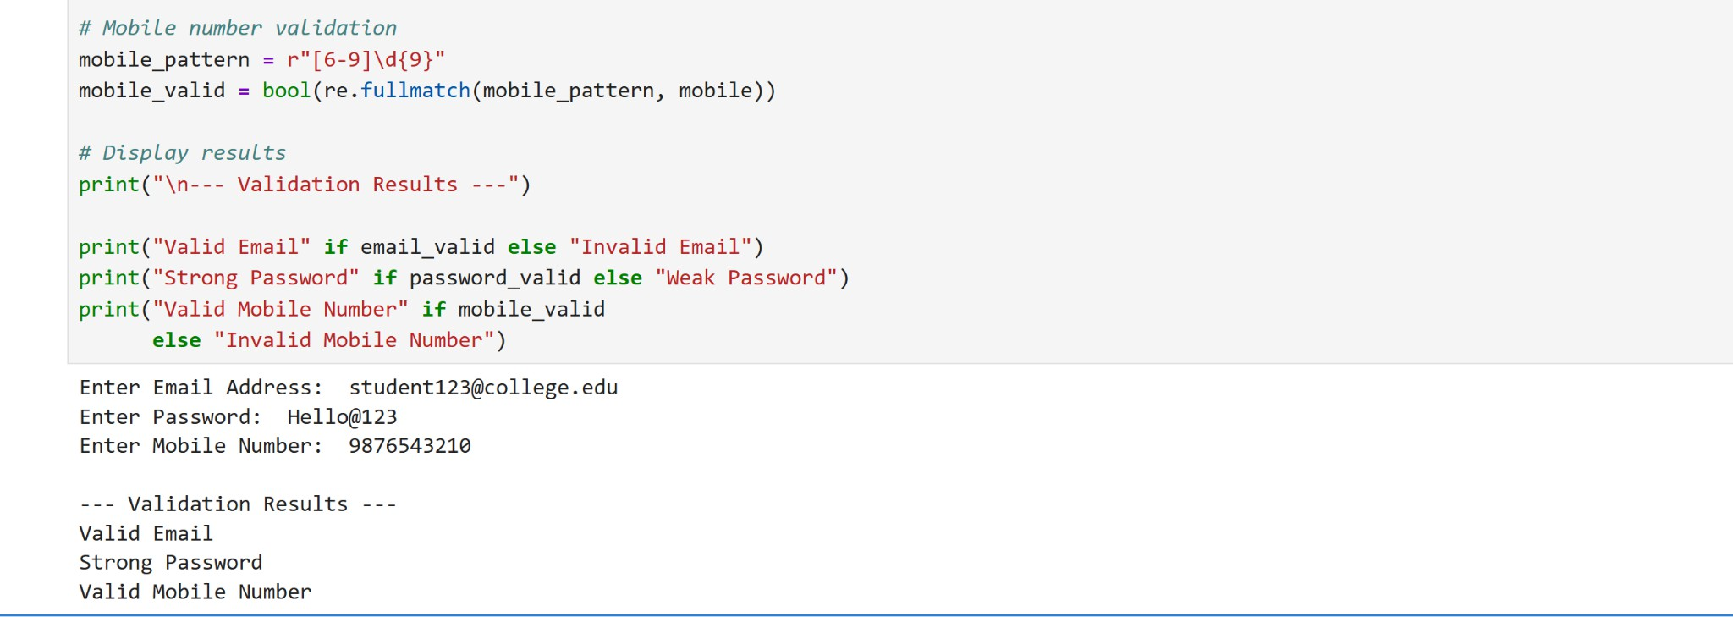

8. Conclusion
The application uses Python's Regular Expressions to validate email addresses, password strength, and mobile numbers. It applies predefined rules and displays clear validation messages, providing a simple, intermediate-level implementation of input validation for a user registration system.

Note: The email pattern follows the specified simplified rules. It intentionally does not support every possible valid email format, and successful pattern matching does not confirm that an email address or mobile number actually exists.

Section 2: Design a Finite State Automata (FSA) Simulator
- Problem Statement

Develop a Python-based Deterministic Finite Automata (DFA) simulator.

The program should:
  - Accept the DFA description
    - States
    - Input alphabet
    - Transition table
    - Initial state
    - Final state(s)
  - Accept multiple input strings.
  - Simulate state transitions.
  - Display whether the string is Accepted or Rejected.
Example

Language:
Strings ending with "ab"

Input
abaab

Output

Transition Path:
q0 → q1 → q0 → q1 → q2 Accepted
Answer:

Section 2: Design a Finite State Automata (FSA) Simulator
- Aim
To develop a Python-based Deterministic Finite Automaton (DFA) simulator that accepts a DFA description, processes multiple input strings, simulates state transitions, and determines whether each string is accepted or rejected.

- Implementation Approach
Step 1: Define the DFA

Specify the set of states, input alphabet, transition table, initial state, and final states. Step 2: Create the Transition Table
Store the transitions using a Python dictionary. Each state and input symbol determine the next state. Step 3: Accept Input Strings
Allow the user to enter multiple strings to test against the DFA. Step 4: Simulate State Transitions
Start from the initial state and process each input character one by one. Use the transition table to determine the next state and record the transition path.

Step 5: Check Acceptance

After processing the entire string, check whether the current state belongs to the set of final states. If it does, the string is accepted; otherwise, it is rejected.

Step 6: Display Results

Display the transition path and the final acceptance status for each input string.

- Key Part of the Algorithm
  - Initialize the DFA states, alphabet, transition table, initial state, and final states.
  - Read the number of input strings and accept each string.
  - Set the current state to the initial state.
  - For each input symbol, find the next state using the transition table.
  - Record each state in the transition path.
  - Check whether the final state is an accepting state.
  - Display the transition path and the result. 8.

Python Code
# DFA Simulator for strings ending with "ab"

# DFA description
states = ["q0", "q1", "q2"] alphabet = ["a", "b"] initial_state = "q0" final_states = ["q2"]

# Transition table transitions = {
"q0": {"a": "q1", "b": "q0"},
"q1": {"a": "q1", "b": "q2"},
"q2": {"a": "q1", "b": "q0"}
}

# Function to simulate DFA def simulate_dfa(string):
current_state = initial_state path = [current_state]

for symbol in string:
if symbol not in alphabet:
print("Invalid input symbol:", symbol) return

current_state = transitions[current_state][symbol] path.append(current_state)

print("Input String:", string) print("Transition Path:", " -> ".join(path))

if current_state in final_states: print("Result: Accepted")
else:
print("Result: Rejected") print()

# Accept multiple input strings
n = int(input("Enter number of strings: "))

for i in range(n):
string = input("Enter input string: ") simulate_dfa(string)

Sample Input
Enter number of strings: 3 Enter input string: abaab Enter input string: aabb Enter input string: ab

Expected Output
Input String: abaab
Transition Path: q0 -> q1 -> q1 -> q2 -> q1 -> q2 Result: Accepted

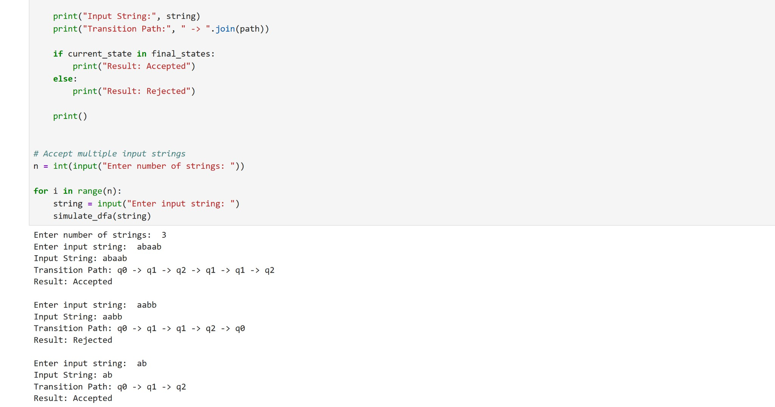
Input String: aabb
Transition Path: q0 -> q1 -> q1 -> q2 -> q0 Result: Rejected
Input String: ab
Transition Path: q0 -> q1 -> q2 Result: Accepted

Conclusion
The DFA simulator demonstrates how a Deterministic Finite Automaton processes input strings using a transition table. It tracks state transitions and determines acceptance based on the final state. The implementation uses Python dictionaries, loops, lists, and conditional statements to simulate a finite automaton in a simple and understandable way.

Section 3: Smart Pattern Matching Engine using Regular Expressions
3. Problem Statement

Develop a Python-based text search engine that performs pattern matching using Regular Expressions.

The system should support:
Word Search Prefix Search Suffix Search Date Search
Phone Number Search Hashtag Search
Mention (@username) Search

Example Input Meeting on 12/09/2026 Call 9876543210 #NLP
@OpenAI
natural language processing

User Menu
- Search Date
- Search Phone Number
- Search Hashtag
- Search Mention
- Search Prefix
- Search Suffix

Expected Output
Display all matching patterns based on user selection.

Section 3: Smart Pattern Matching Engine using Regular Expressions

Aim
To develop a Python-based text search engine using Regular Expressions (Regex) to identify words, prefixes, suffixes, dates, phone numbers, hashtags, and mentions from a given text.

Implementation Approach
Step 1: Input Text

Accept a paragraph or a collection of text from the user. This text acts as the source for pattern matching. Step 2: Define Regex Patterns
Create suitable regular expression patterns for dates, phone numbers, hashtags, mentions, prefixes, and suffixes.

Step 3: Select Search Operation

Display a menu that allows the user to choose the required search operation.

Step 4: Perform Pattern Matching

Use Python's re.findall() function to find all matching patterns in the text. Use re.escape() when including a user-provided keyword in a pattern.

Step 5: Display Results

Display all matching items for the selected operation. If no matches are found, display an appropriate message. Step 6: Repeat Searches
Allow the user to perform multiple searches on the same text until they choose to exit.

Key Part of the Algorithm
  - Read the input text.
  - Define Regex patterns for dates, phone numbers, hashtags, mentions, words, prefixes, and suffixes.
  - Display a menu containing the available search operations.
  - Accept the user's choice and any required search keyword.
  - Apply the corresponding Regex pattern using re.findall().
  - Display all matching patterns or a message indicating that no matches were found.
  - Repeat the process until the user selects Exit.

Python Code
import re

# Input text
text = input("Enter text to search: ")

# Function to perform pattern matching def search_pattern(choice):

if choice == 1:
# Search dates in DD/MM/YYYY format pattern = r"\b\d{2}/\d{2}/\d{4}\b"

elif choice == 2:
# Search 10-digit mobile numbers pattern = r"\b[6-9]\d{9}\b"

elif choice == 3:
# Search hashtags
pattern = r"(?<!\w)#[A-Za-z0-9_]+"

elif choice == 4:
# Search @username mentions pattern = r"(?<!\w)@[A-Za-z0-9_]+"

elif choice == 5: # Prefix search
prefix = input("Enter prefix: ")
pattern = r"\b" + re.escape(prefix) + r"\w*"

elif choice == 6: # Suffix search
suffix = input("Enter suffix: ")
pattern = r"\b\w*" + re.escape(suffix) + r"\b"

elif choice == 7: # Word search

word = input("Enter word: ")
pattern = r"\b" + re.escape(word) + r"\b"

else:
print("Invalid choice!") return

# Find matching patterns
matches = re.findall(pattern, text, re.IGNORECASE)

# Display results if matches:
print("Matching Patterns:") for item in matches:
print(item)
print("Total Matches:", len(matches)) else:
print("No matching patterns found.")

# Menu while True:
print("\n--- Smart Pattern Matching Engine ---") print("1. Search Date")
print("2. Search Phone Number") print("3. Search Hashtag") print("4. Search Mention") print("5. Search Prefix")
print("6. Search Suffix") print("7. Search Word") print("0. Exit")
choice = int(input("Enter your choice: ")) if choice == 0:
print("Search engine closed.") break
search_pattern(choice)

Sample Input
Meeting on 12/09/2026 Call 9876543210 #NLP
@OpenAI
natural language processing

Enter the complete text as a single line when prompted, or modify the input statement to accept multiple lines. For example:
Meeting on 12/09/2026 Call 9876543210 #NLP @OpenAI natural language processing

Sample Output
For menu option 1 (Search Date): Matching Patterns:
12/09/2026

Total Matches: 1
For menu option 3 (Search Hashtag): Matching Patterns:
#NLP
Total Matches: 1
For menu option 4 (Search Mention): Matching Patterns:
@OpenAI
Total Matches: 1

Important Regex Patterns

Pattern | Purpose
\d{2}/\d{2}/\d{ 4} | Matches dates in DD/MM/YYYY format
[6-9]\d{9} | Matches 10-digit Indian mobile numbers
#[A-Za-z0-9_]+ | Matches hashtags
@[A-Za-z0-9_]+ | Matches username mentions
\b | Identifies word boundaries
re.findall() | Returns all matching patterns

Conclusion
The Smart Pattern Matching Engine uses Python's Regular Expressions to search text for different patterns, including dates, mobile numbers, hashtags, mentions, prefixes, suffixes, and specific words. The menu-driven implementation demonstrates practical text processing using Regex, functions, loops, and conditional statements.

Note: The date pattern checks the format, not whether a date exists on the calendar. Similarly, matching a phone number's format does not verify that the number is active.

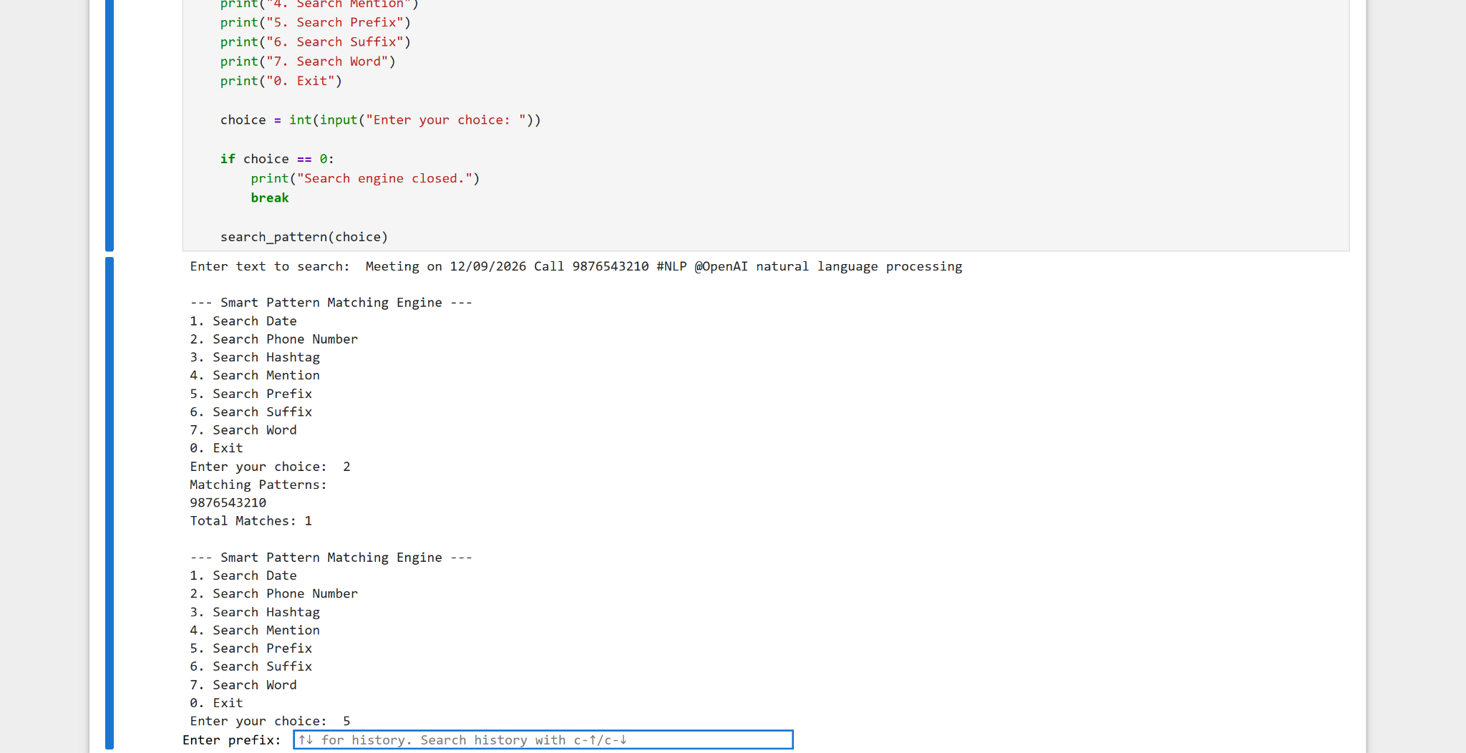

Rubrics for Calculation

Criteria | Weightag e | Level 4 – Exemplary | Level 3 – Proficient | Level 2 – Developing | Level 1 – Beginning
Problem Understanding | 20% | Clearly understands problem constraints, edge cases, and competitive requirements | Understands problem with minor gaps in constraints | Partial understanding; misses key constraints | Misinterprets problem or constraints
Algorithm | 25% | Selects optimal algorithm with best time and space complexity for competitive  constraints | Uses efficient algorithm with minor scope for improvement | Uses basic/inefficient approach | No clear algorithmic approach
Code Implementation | 20% | Writes correct, efficient, and clean code that passes all constraints | Code works with minor errors or inefficiencies | Partially correct code; fails for some cases | Code does not execute or gives incorrect results
Competitive Performance | 20% | Solves problem within time limits and handles large  inputs effectively | Solves within acceptable time with minor delays | Struggles with time limits or larger inputs | Unable to solve within time constraints
Test Case Handling | 15% | Handles all test cases including edge and hidden cases | Handles most test cases | Misses important edge cases | Fails on multiple test cases

Q. No. / Criteria | Problem Understandi ng | Algorithm | Code Implementat ion | Competitive Performance | Test Case Handling | Sub. Total | Total  %
1
2
3

Faculty In-charge | Course Coordinator | Program Director
Signature: | Signature: | Signature:
Date: | Date: | Date:

